**EC2 TASKS-**

*Using one EC2 instance installing through Git Bash*

* ***DOCKER***

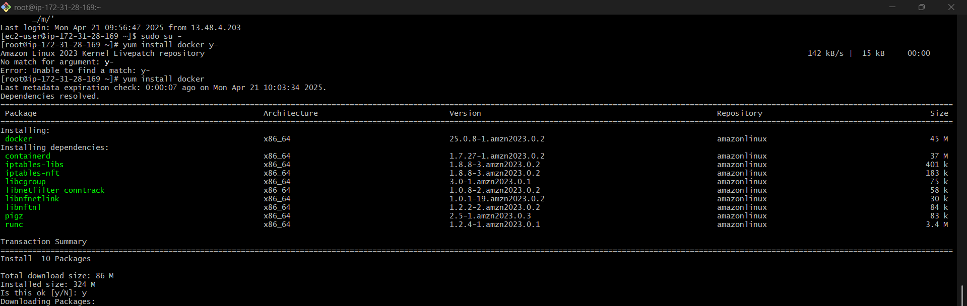



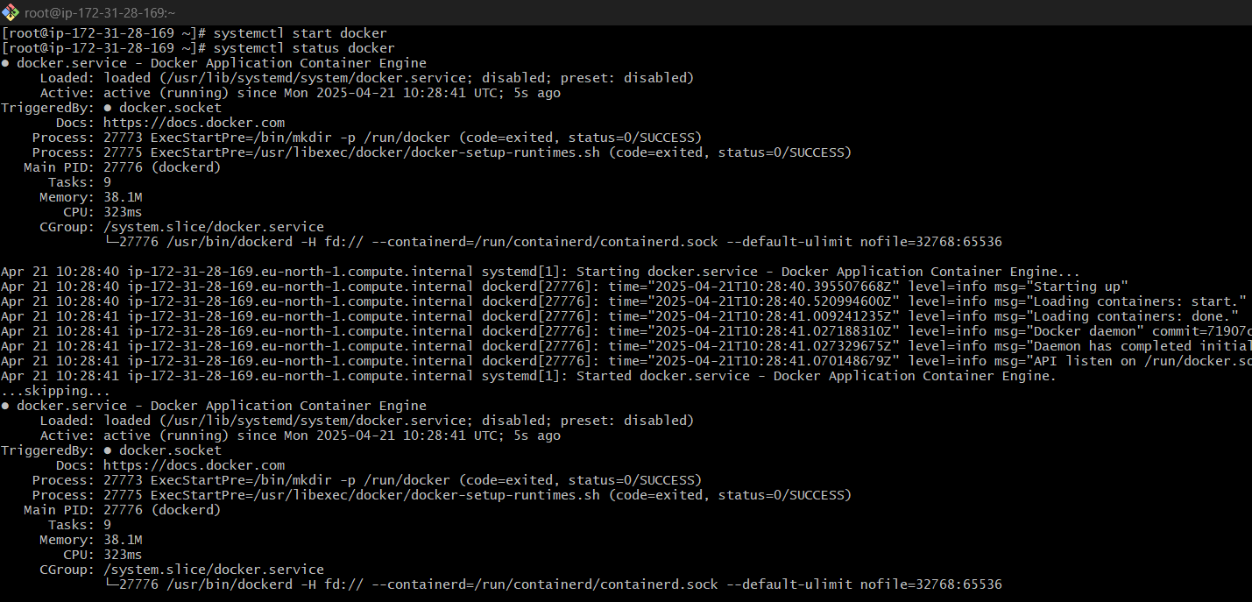

* ***JENKINS***

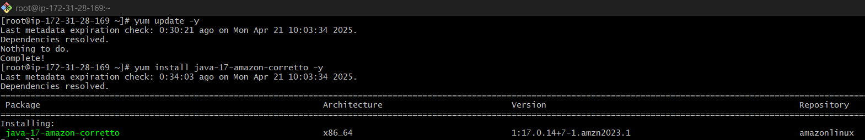

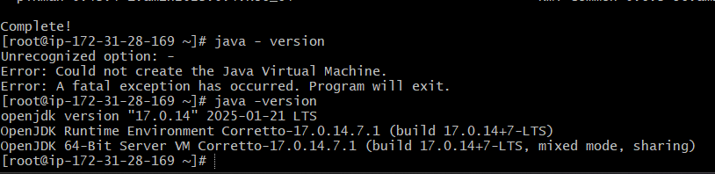

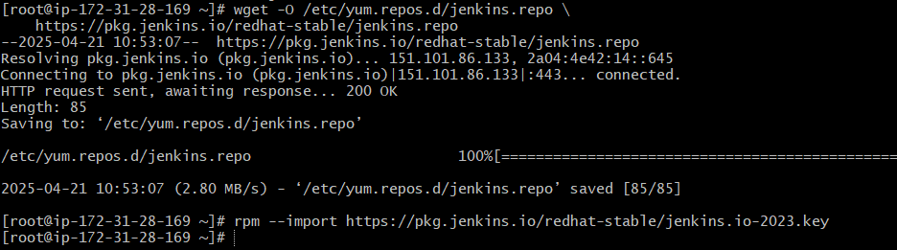

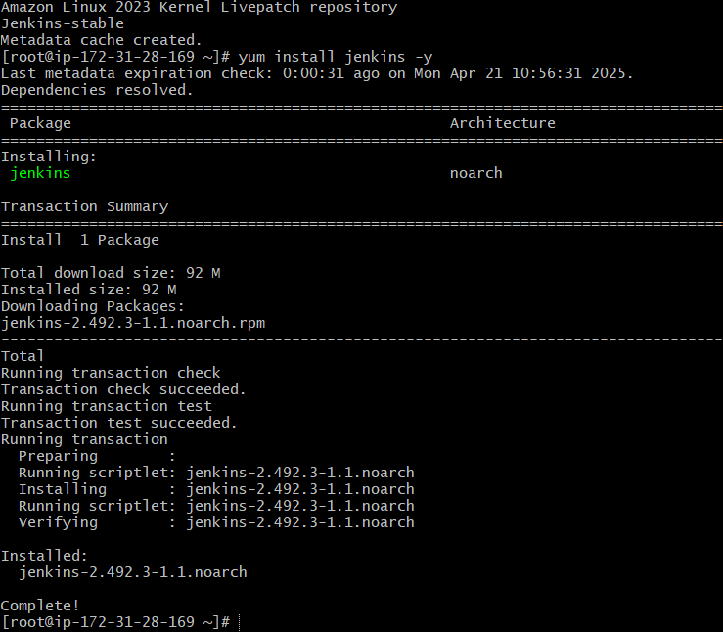

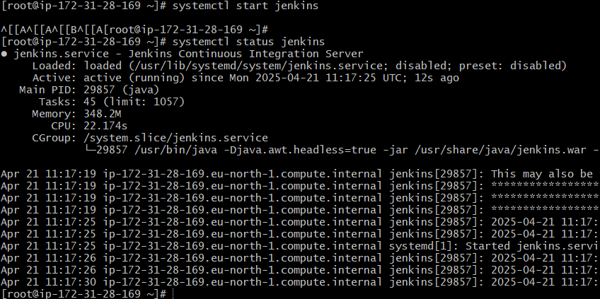

* ***Apache HTTP Server(httpd)***

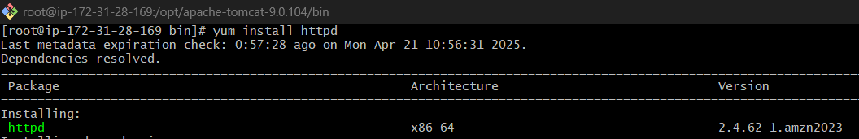

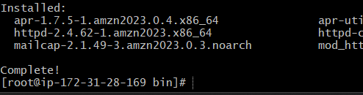

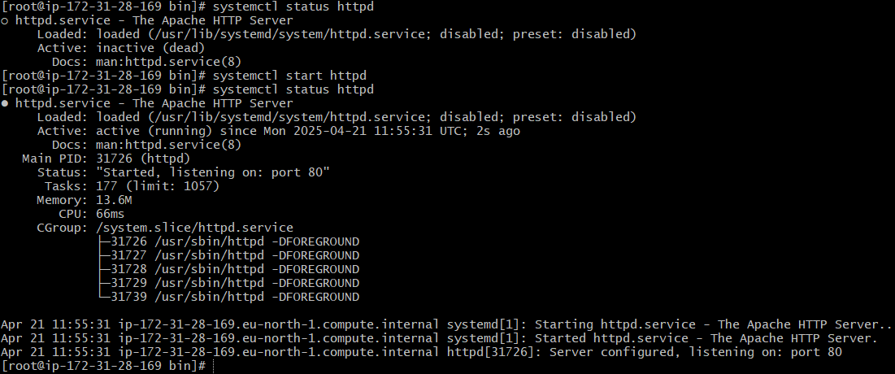

* ***NGINX***

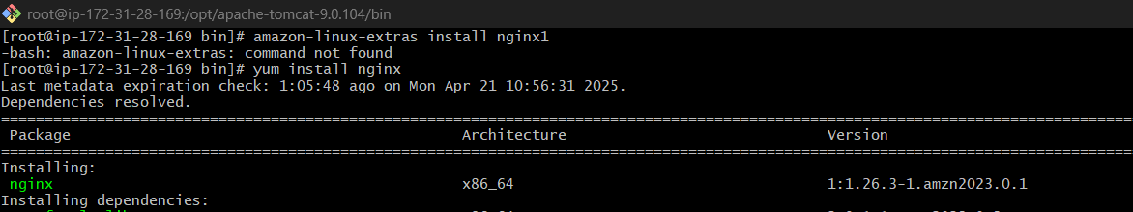

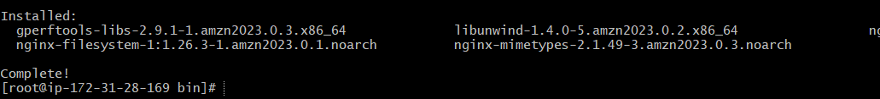

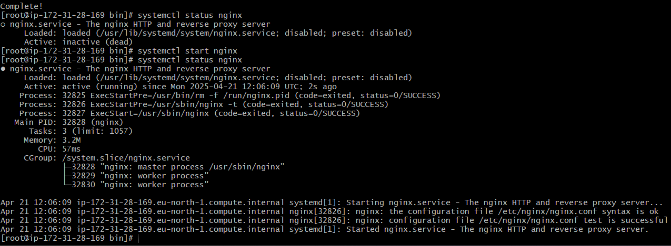

* ***APACHE TOMCAT***



